INTER HOUSE TABLE TENNIS TOURNAMENT FOR PRIMARY WING
2016-2017

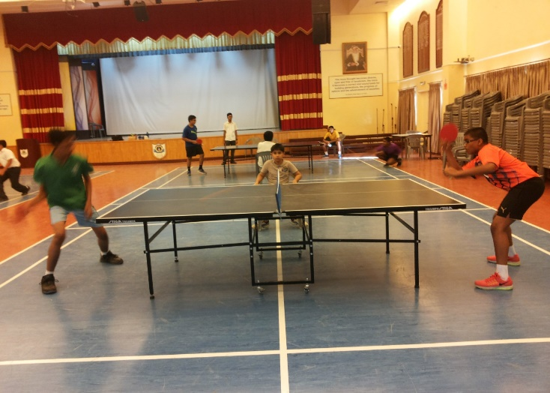

The Inter House Table Tennis tournament for the students of primary wing morning and afternoon shift will held on third week of November2016. The training classes for the students interested will be conducted in senior school M. P. Hall on the following days.

S. No | Days | Timings | Shift | Shift | Category
 | Sunday, Monday,  Tuesday, Wednesday | 2:30 pm to 4:00 pm | Morning Shift | - | Boys & Girls
 | Friday, Saturday | 4:00 pm to 6:00 pm |  | Afternoon shift | Boys & Girls

For any clarification kindly contact Ms. Premlata at G.S.M 92699838.

