INTERNATIONAL DAY OF FAMILIES CELEBRATION
Date: 11th May 2017 Time: 4.00 PM
“You don't choose your family. They are God's gift to you, as you are to them.”

Family is a bond that keeps us together through thick and thin and Family Day is the day where we celebrate this special bond. It is through a family that we learn the values of love, trust, hope, belief, culture and traditions. It is a gift not only of lovable parents, but also of siblings who care and love us beyond themselves. One should always thank God for the blessings of having a family that cares and loves us. It is the greatest blessing any person could ever get in life.
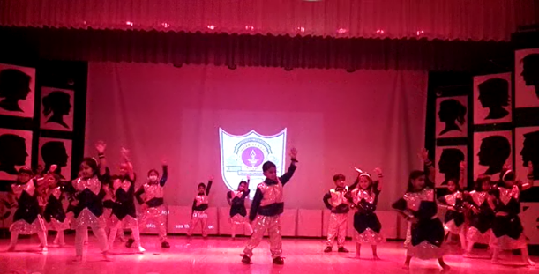
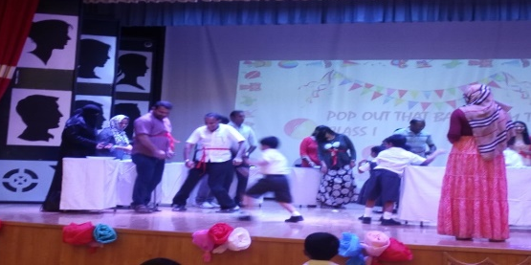
The International Day of Families was celebrated at the M.P Hall, ISWK Senior School by classes I and II students, parents and teachers. On this day the families came together and celebrated the joy of being one as a family. Some parents expressed their views and gratitude which was appreciated by all. The children entertained the gathering with a beautiful song on the family and later through a fantastic dance performance. There was lots of fun. Many games were conducted where each family worked as a team and enjoyed themselves. It truly was a day to remember and cherish by each and every family present that evening.
