

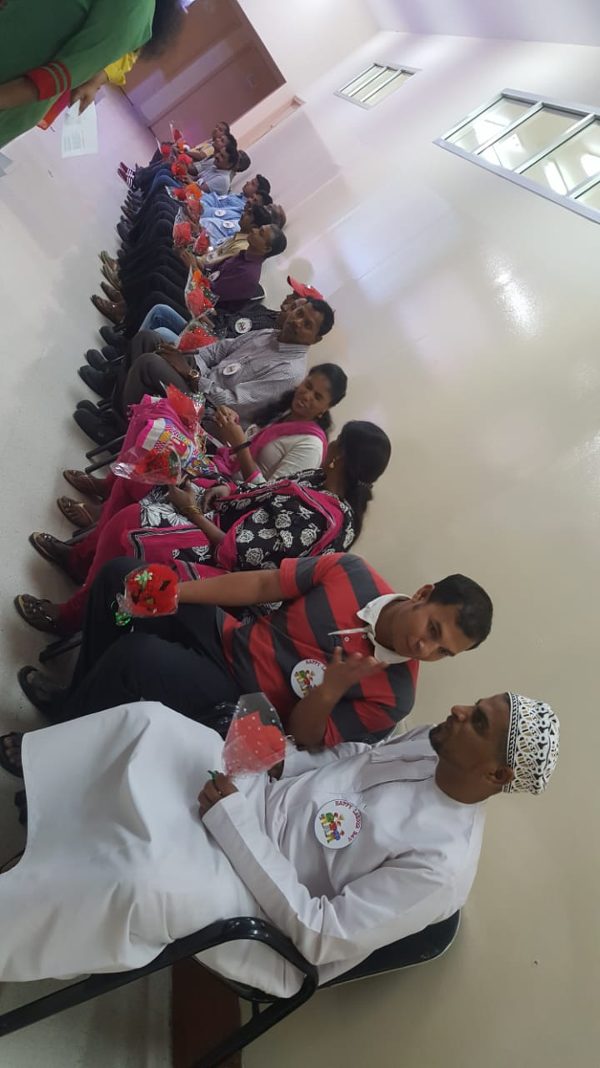

International Worker’s Day also known as Labour Day or May Day is celebrated on May 1st every year.

We at Indian School Al Wadi Al Kabir, Primary Wing, Afternoon Shift celebrated this occasion with the motive to *show gratitude to all our workers*. In honour of all the support staff of ISWK, Primary Wing, an assembly was organized in the Penthouse on 1st of May 2019.

All the support staff of the Afternoon Shift were invited. The staff and students performed for them and organised songs and games which made them feel so special!

Events like streaming of live video clips of our support staff, fun games, a raffle draw, a special song, cutting of a cake and serving sumptuous delicacies were the highlights of the assembly!

It truly was an evening to remember and both, the staff and students as well as the support staff were filled with joy and appreciation.

“ALL LABOUR THAT UPLIFTS HUMANITY HAS DIGNITY AND IMPORTANCE AND SHOULD BE UNDERTAKEN WITH PAINSTAKING EXCELLENCE” – *Martin Luther King*.

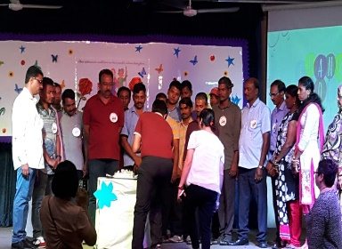 I 