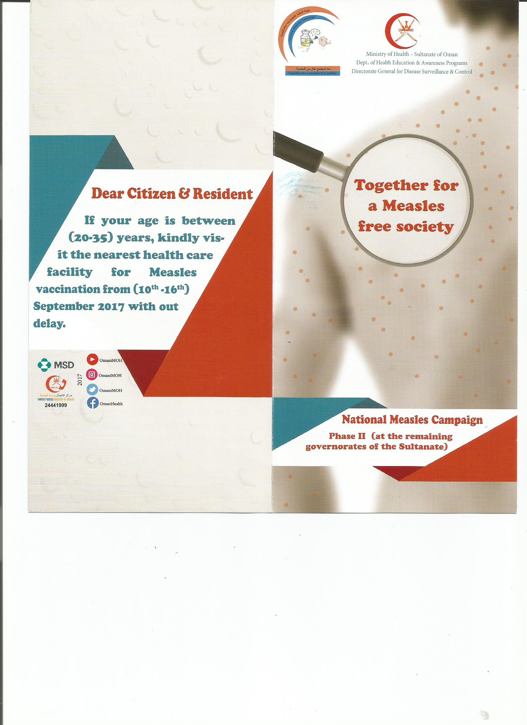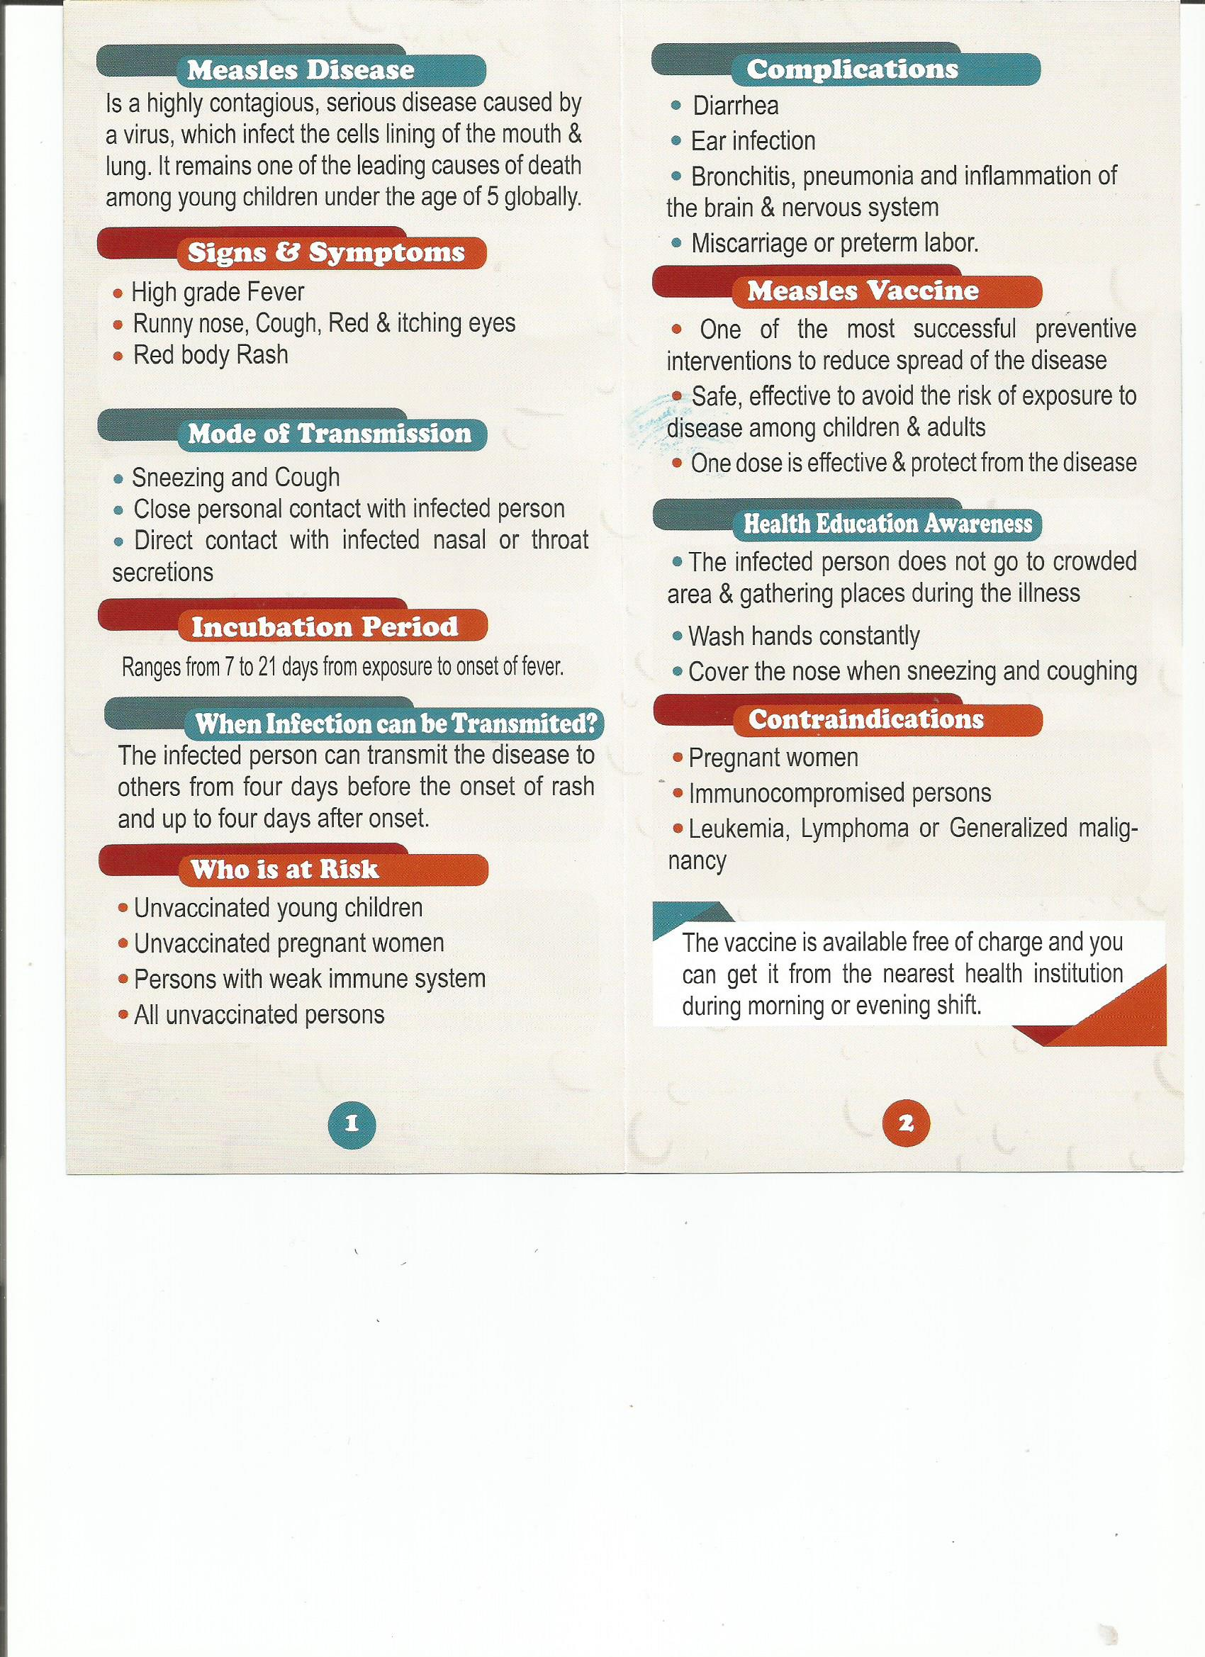

**NATIONAL MEASLES CAMPAIGN BY MINISTRY OF HEALTH, OMAN**