Mothers’Day Special Assembly
Afternoon Shift (2019-2020)
Mother's Day is an occasion which is celebrated in various parts of the world to express respect, honour, and love towards mothers. The day is an event to honour the contribution of mothers, acknowledge the efforts of maternal bonds and the role of mothers in our society.
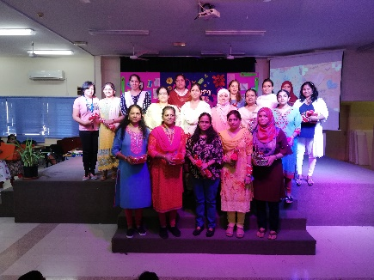
Mothers’ day was celebrated on the 16th of May 2019 by conducting a special assembly in the penthouse. The programme was scheduled with three different kinds of activities for classes 3, 4 and 5 respectively. Class 3 made beautiful cards for their mothers which were added to the PPT during the assembly. Class 4 presented beautiful messages for their mothers and the best three from each class was selected and read out during the assembly. Class 5 wrote poems on their mothers and the best three were made read out during the assembly.
The assembly started with a video of famous personalities’ quotes followed by the welcome address. Then a video was shown on ‘Why Mother’s Day is celebrated’, which was followed by the above mentioned activities of classes 4 and 5. A beautiful dance was put up by the children of class 5. Srilakshmi of class 5 (dressed up as mother) gave a fantastic message to the children and then all the children together wished their mothers with a melancholic song ‘Happy Mother’s Day’. Our Vice- Principal was invited to address the students. He advised the children to go home and wish their mothers with a huge hug and a kiss. The assembly concluded with the vote of thanks.
The assembly was organised well and each child left the penthouse with a message for his/her loving mother.
