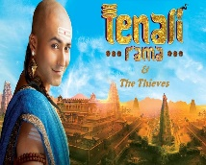  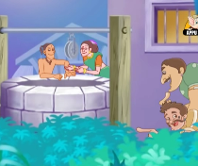  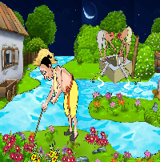  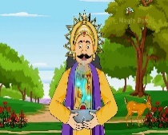 | ENGLISH STORYTELLING COMPETITION (2019-2020)  A wise man once said, “After nourishment, shelter and companionship, stories are the thing we need most in the world.” It’s the stories that give wings to our imagination and take us to places beyond the boundaries of our physical world and into the land of fairies, dragons and wishing trees. It is in our imagination that we embrace things and situations that we shy away from the real world. Since time immemorial, storytelling has been an integral part of our childhood. To keep the tradition going and to incite curiosity and the love for reading in children, a Story Telling Competition was held as part of an Inter Class Activity on August 28, 2019.  Children narrated stories from folk tales based on the themes: Birbal’s wisdom/ Tenali Raman’s wit and intelligence. To captivate the audiences’ attention and to make the narration interesting, the narrators donned the avatars of the characters and used props and power point presentations. The participants made effective use of facial expressions, gestures and voice modulation.  The participants who made it to the final round were Shrushti Hegde, Lokesh Ayyappan, Ayesha Juned Deshmukh, Avneetpal Kaur, Siya Shiju, Shaaswath Srinath, Madhav Ashok, Heba Amra Nehru Sheriff, Niya Ann Neuby, Shresth Kumar Gupta and Drishti Hegde.  The competition was judged by Mrs. Minu Thomas, Mr.Ragesh and Mrs. Revathi Torres. As the competition was intense, the judges had a difficult time in choosing the winner. The winners and participants were rewarded with prizes and certificates.  The event ended with the Vice Principal, Mr. Ernst Schwan giving his insights on diction and pronunciation to help the students take their performances a notch higher.  WINNERS  POSITION CLASS/SEC NAME OF THE STUDENT  1ST II L MADHAV ASHOK  2ND II L HEBA AMRA NEHRU SHERIFF  3RD II L SHRESTH KUMAR GUPTA | 