***G. K QUIZ COMPETITION***

***CLASS IV (2017-18) (Afternoon shift)***

**Class IV Inter-section General Knowledge Quiz Competition was held on 25th October 2017. Students of classes IV K, IV L & IV M participated enthusiastically. There were 6 rounds in all comprising of questions from the G.K book, current affairs, audio visual rounds and the final rapid fire round. These gave the teams a chance to recall the syllabus covered and to put –up a tough fight. The current affairs round ensured that the teams minutely read every details in the newspaper through the week gone by. A healthy competition was witnessed with full participation of all the six teams consisting of 4 participants in each team.**

**The rules of the inter-section quiz competition were announced by the quiz master. The teams skillfully answered the questions asked. The audience also got a chance to participate. Everyone waited with baited breaths for the announcement of the final scores. The Issac Newton team won the Quiz Competition. The Alexander Graham Bell team came in with a close second place. Everyone cheered for the winning teams.**

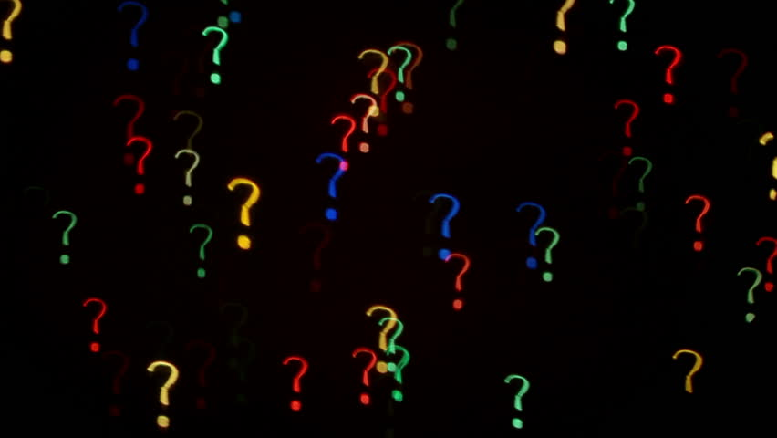

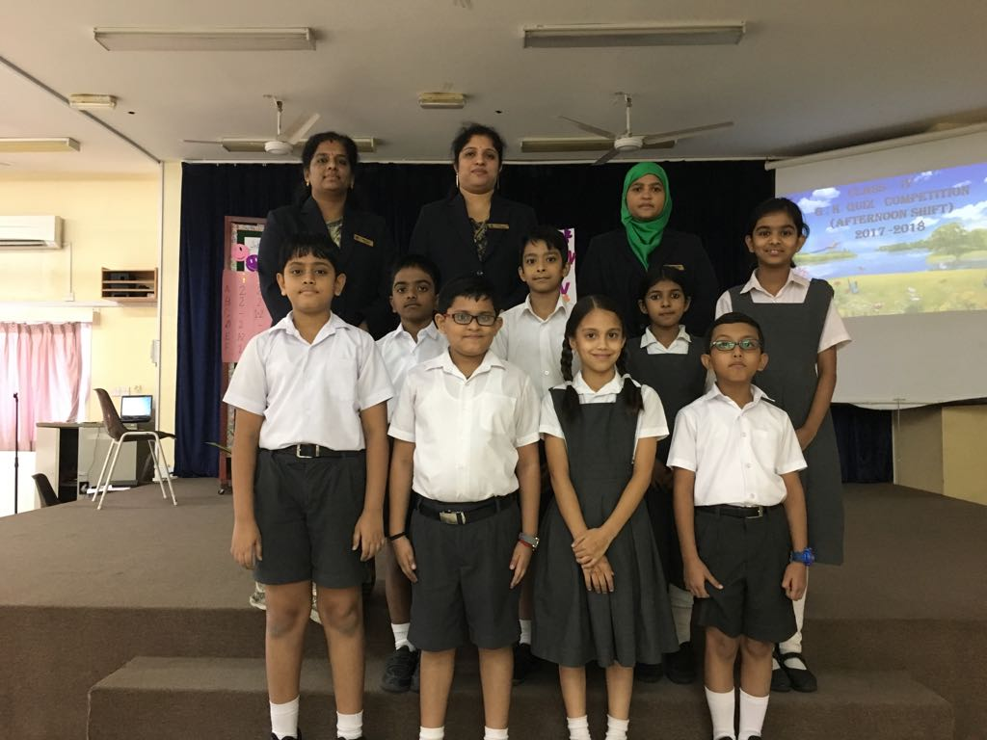 

Winners of the G.K Quiz Competition

First Place – Class IV L

1. Amrithatman Swarupam
2. Gauthum Krishna .D
3. Siddarth Anitha Rajesh
4. Abhimata Ojha

Winners of the G.K Quiz Competition

Second Place – Class IV K

1.Aarjav Vipin

2.Areebah Fathima

3.Diya Fathima

4.Muhammed Muhsin

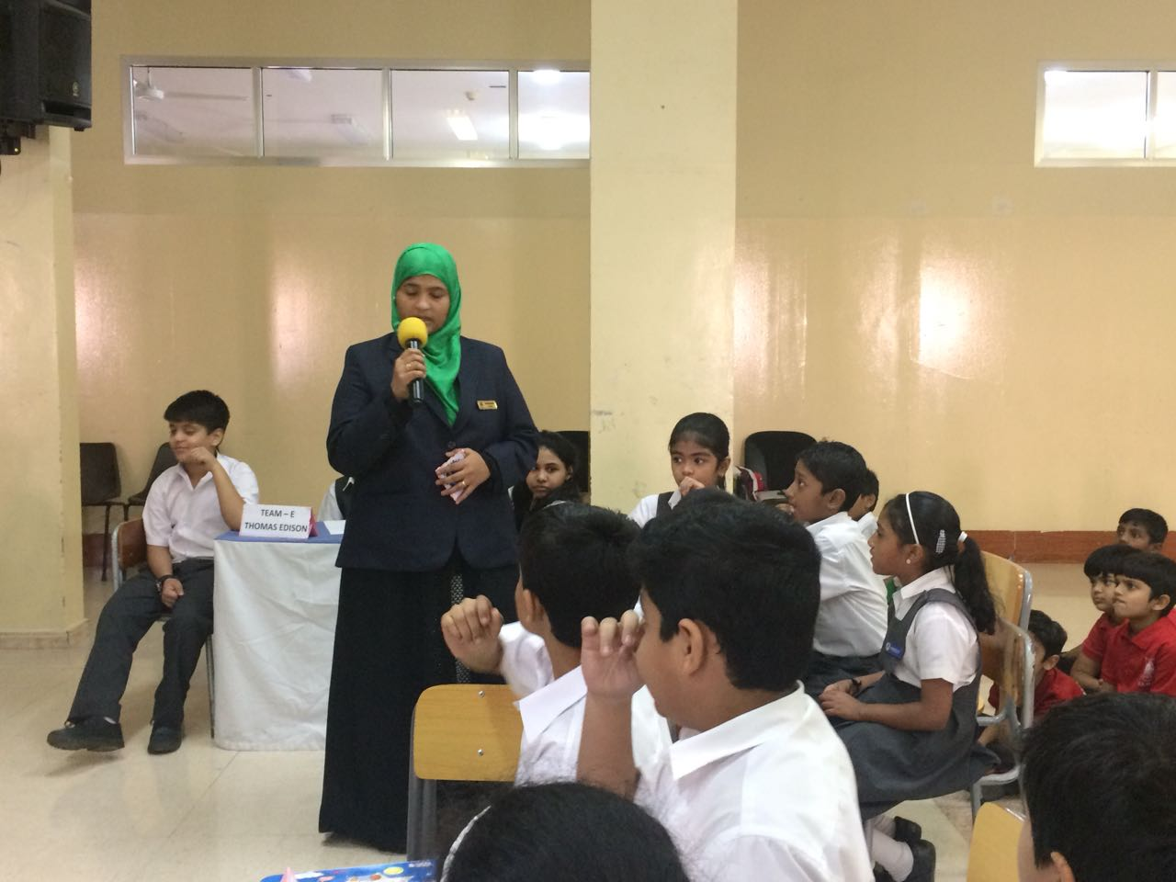 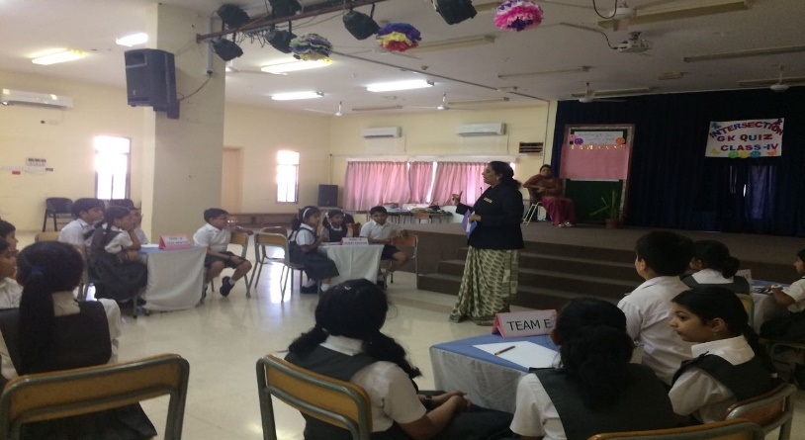

Glimpses of THE G.K. ROUNDS

