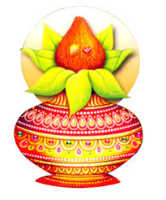
s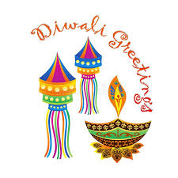
INDIAN SCHOOL AL WADI AL KABIR
[ MORNING SHIFT]
DIWALI ASSEMBLY
DATE : 21ST OCTOBER 2019
VENUE : PRIMARY WING [ISWK ]

Diwali is one of the most popular festival of Hindus. Diwali symbolizes the spiritual
‘ Victory’ of light over darkness, good over evil and knowledge over ignorance’.
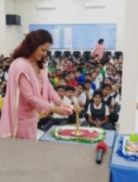
A special Diwali Assembly was conducted by the students of class IV J, V E & V C to mark the occasion.
The assembly began with the traditional lighting of the lamp ceremony by the honorable Vice - Principal, Mrs Shasikala Prabhat.

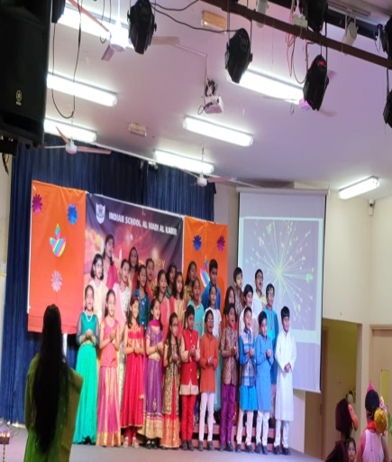
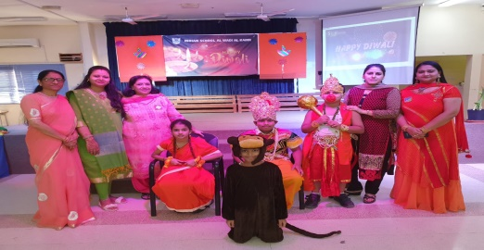
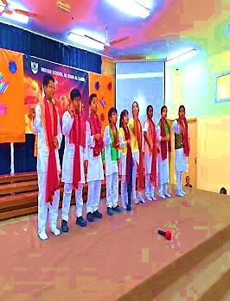
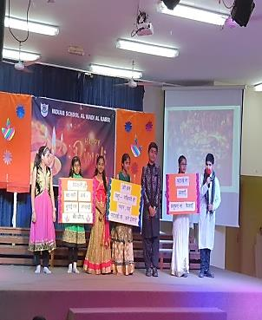
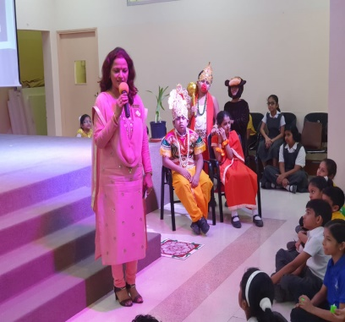
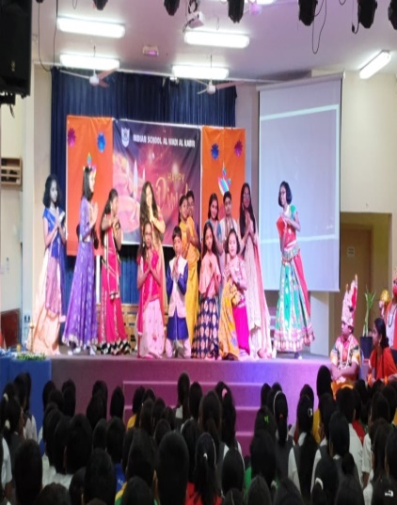
The students of class V C presented a skit with the message ‘No to crackers, No to pollution, save the mother earth .’ The special assembly conveyed the strong message of cracker free Diwali.

