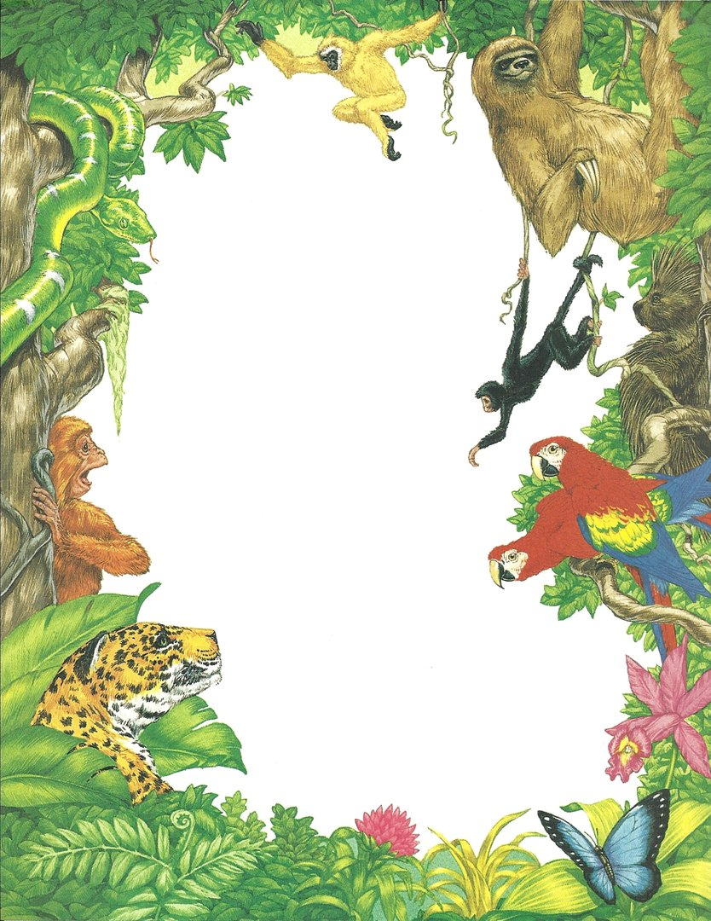

**Earth Day** is celebrated on 22nd April annually; marking the anniversary of the birth of the modern environmental movement in 1970. Various events are held worldwide to demonstrate support for [environmental protection](https://en.wikipedia.org/wiki/Environmental_protection).

A Special Assembly was held at Indian School Al Wadi Al-Kabir, Primary (Morning Shift) by the students of classes **I A** and **II C** to mark the occasion. In keeping with the theme for Earth Day 2019 – ‘**Protect Our Species**,' the students presented a skit highlighting the consequences of destruction of plant and wildlife populations by human activity such as climate change, deforestation, poaching and pollution. The students recommended and demonstrated ways to overcome the damage done and make the Earth a sanctuary for endangered species. The assembly ended with a melodious song and vibrant dance filling the atmosphere with hope and commitment to work for a better future for various animal species.