

Aerobics is an action packed, dynamic sport that is fast paced and is great for developing health and fitness.

The Inter-House Aerobics Competition was held for the Afternoon Shift on 10th October 2018. The children performed high intensity movement patterns to heart pounding music. Children also carried out a continuous sequence of high and low impact steps.

It was exhilarating to watch the children perform with zeal, enthusiasm and splendor.

The judges Ms. Marissa Pontila Del Rio , Ms. Rouya Lapena and Ms. Surabhi Sameer were enthralled with the performance and at the end took to the stage to show the students a few aerobic moves. The students were thrilled at the enthusiasm and fitness displayed by the judges.

The competition was both a great event and a day to remember by all.

**1st place**

**TAGORE HOUSE**





**CLASS III**

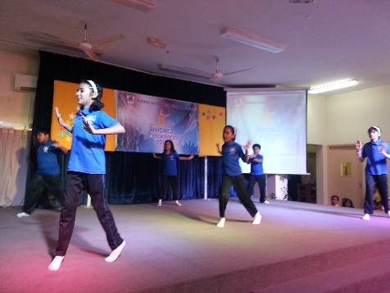

1. ISHA JITHESH

2. NAMEERA KHAN

3. MOIN NOAMAN

4. SYED YAZDAN QUADRI

5. BUSHRA HAQUE

6. SHIVANJALI JAYACHANDRAN

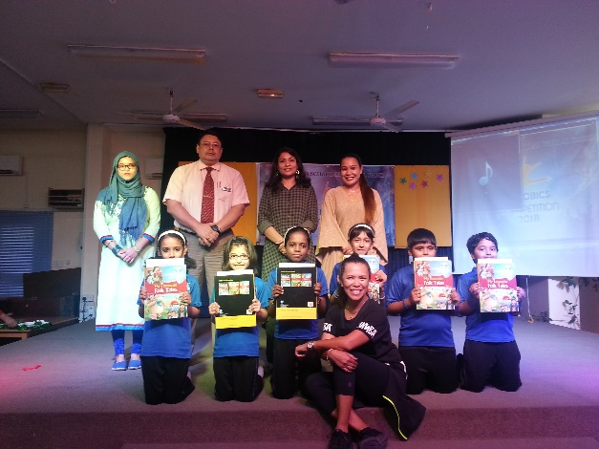



**2nd place**

**ASHOKA HOUSE**

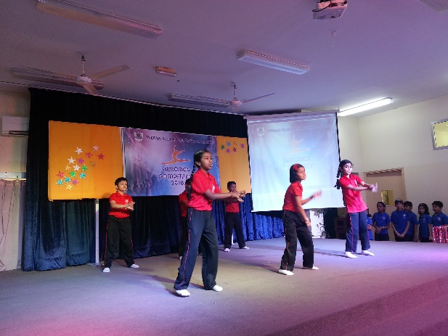

1. ARSLAAN AZIZ

2. VANDHANA SRI

3. ARJUN S. NAIR

4. SARA SHA ALLAM

5. DHRUV B. KOTIAN

6. ALANKRITA GUPTA

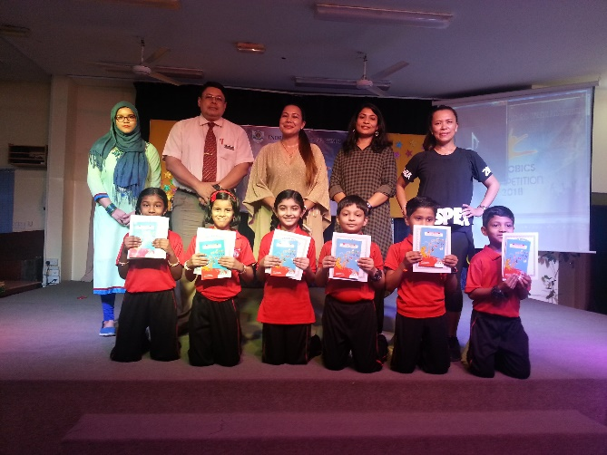



**3RD PLACE**

**AKBAR HOUSE**

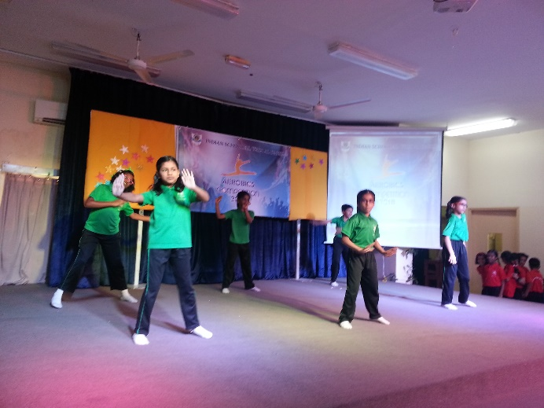

1. ZIQRA V. FAROOQUI

2. SAARANGI JYOTHISH

3. MOHAMMED ARMAAN

4. AKSHAYA BALAGANGADHARAN

5. SIVANANDHITHA MURUGAN NADAR

6. MIA SANAL

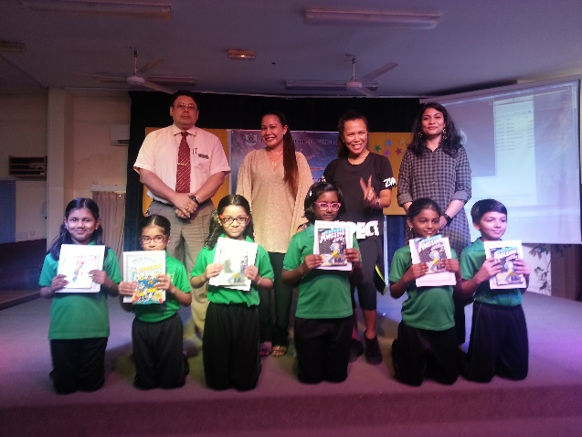







**CLASS IV**

**1ST PLACE**

**ASHOKA HOUSE**

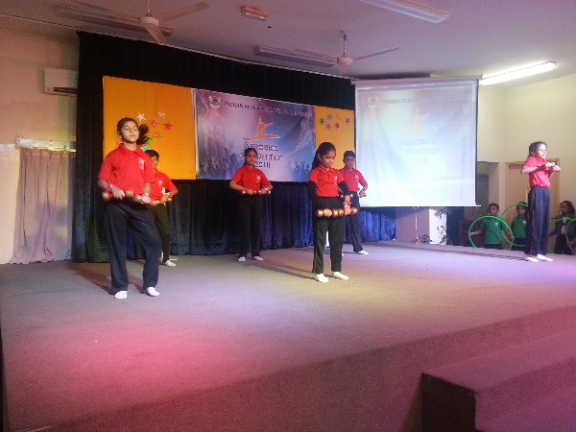

1. RANVEER PRABHATH

2. GRACY GARG

3. RUQAIYA HUSSEIN RAMPURAWALA

4. ALIZA ZAMEER KHAN

5. MAYAN BINU

6. SHENZA SAJEER

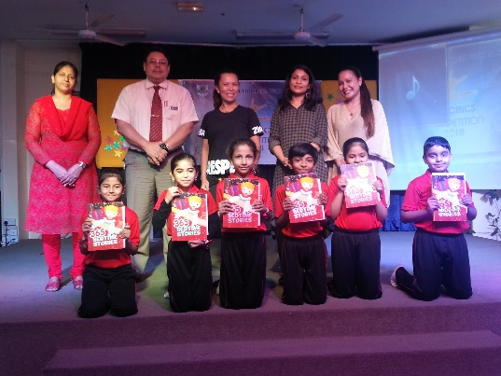

**2ND PLACE**

**VIVEKANANDA HOUSE**

**AND**

**AKBAR HOUSE**

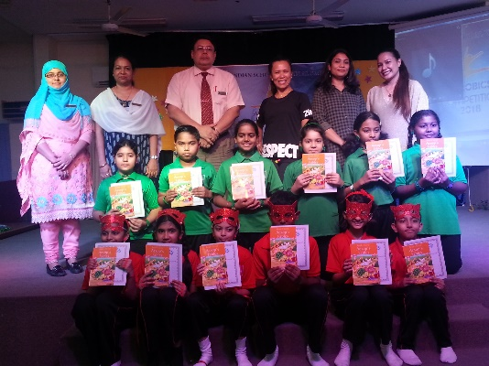

1. DIVYA VENGURLEKAR

2. HIBA NASSEER

3. NIHAL NINU

4. R. SHAIRISHI

5. ADWITA LAKSHMI ASHOK

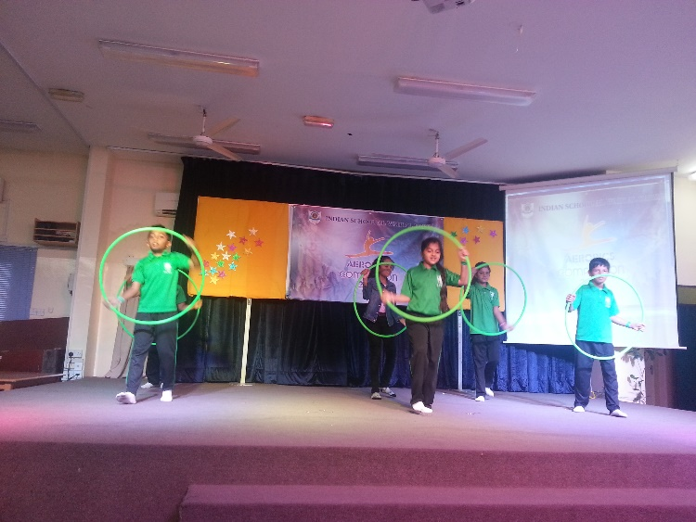

1. ALPLY SAM

2. ANDREA JOHN

3. INICA SHARMA

4. 4. FELIX B. JAMES

5. DAISHA LENORA D’SOUZA

6. MOHAMMED JUNAID

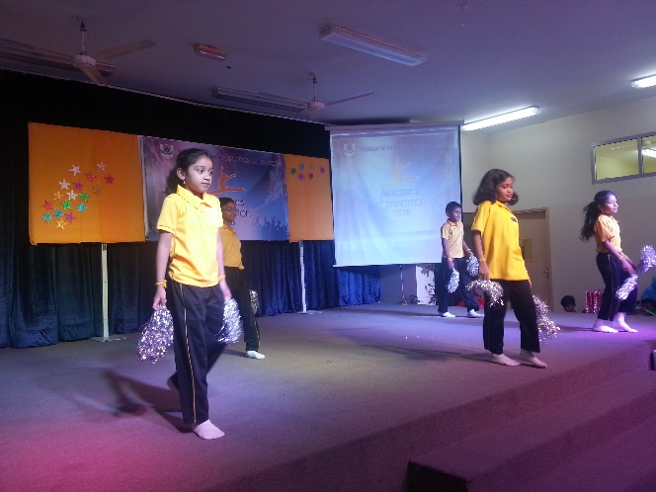



**1ST PLACE**

**VIVEKANANDA HOUSE**

**CLASS V**

1. NORA SHOJAN THAIKKATTIL

2. REBECCA RUBA

3. HAFSA NOURIN

4. AFIYA UMAR USTAD

5. MIRZA ZUHAIB BAIG NUMAIR

6. HRIDAYA VIKRAM CHAPKE

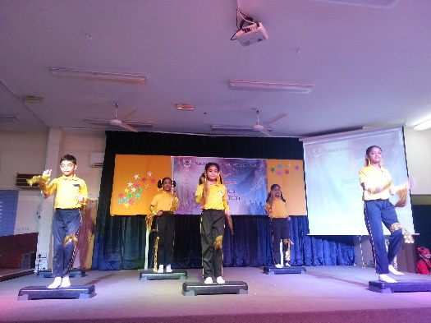

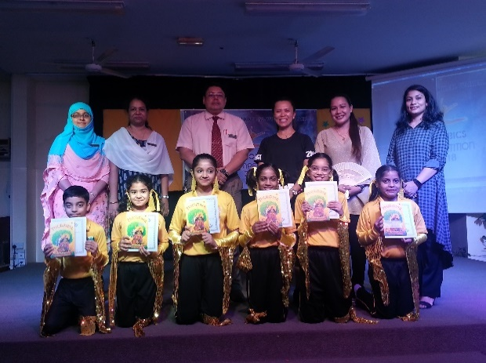



**2ND PLACE**

**TAGORE HOUSE**

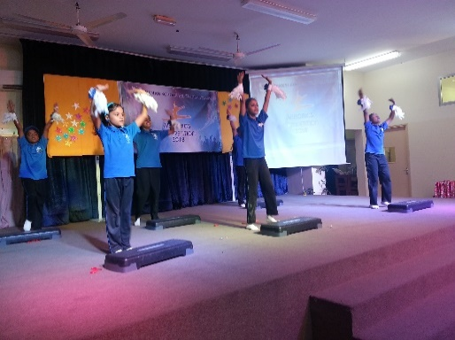

1. MATHIYAZHAGI ANANDHAN

2. GOWRI NANDANA

3. SARA RAICHEL SIJU

4. NIRANJANA VINOD

5. FARHAT FARHAN ANSARI

6. AARJAV VIPIN

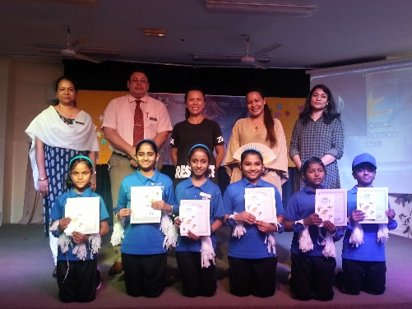

**3RD PLACE**

**AKBAR HOUSE AND ASHOKA HOUSE**

1. EVELYN TRAVaS

2. RAMYA SREE

3. SHRUTHI PUNNA

4. PREAL B. CHOUHAN

5. GOUTHAM KRISHNA D

6. MIHIKA SHETTY

1. SAMREEN SHAHIDSAIT

2. PRASHOBH MANU

3. SAVYONA SARAH SAJI

4. MANASA MANJUNATH

5. AKANSHA B. CHOUHAN

6. AALIYA RIZVI



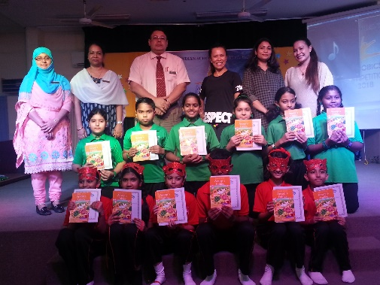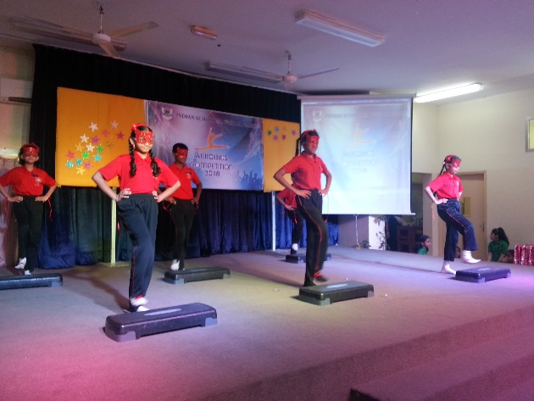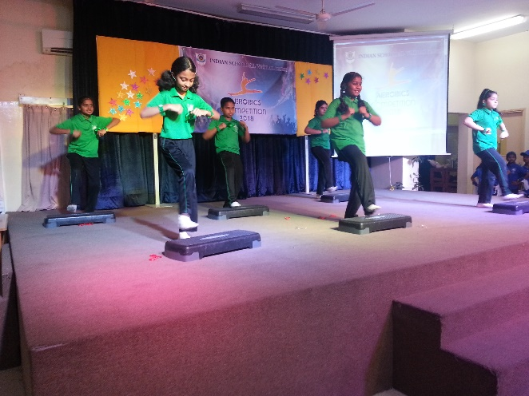



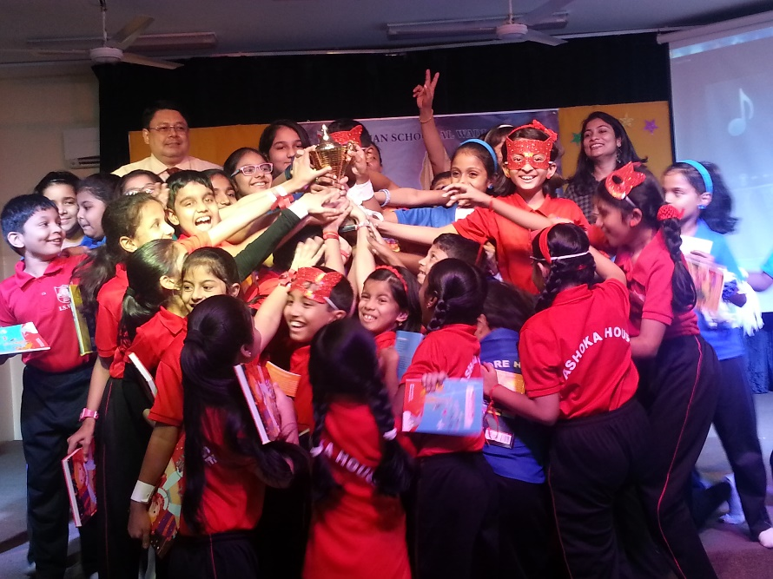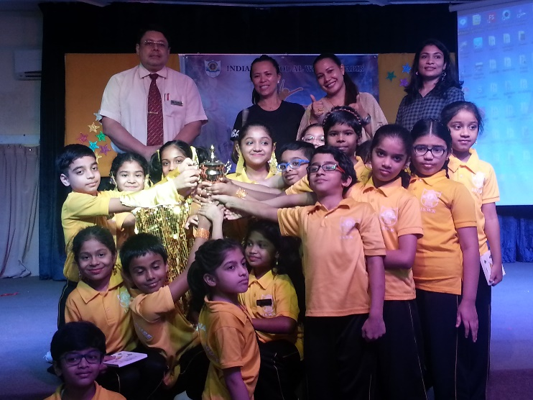

**CHAMPIONSHIP**

**ASHOKA HOUSE**

**AND**

**TAGORE HOUISE**

**Runner up**

**VIVEKANANDA HOUSE**