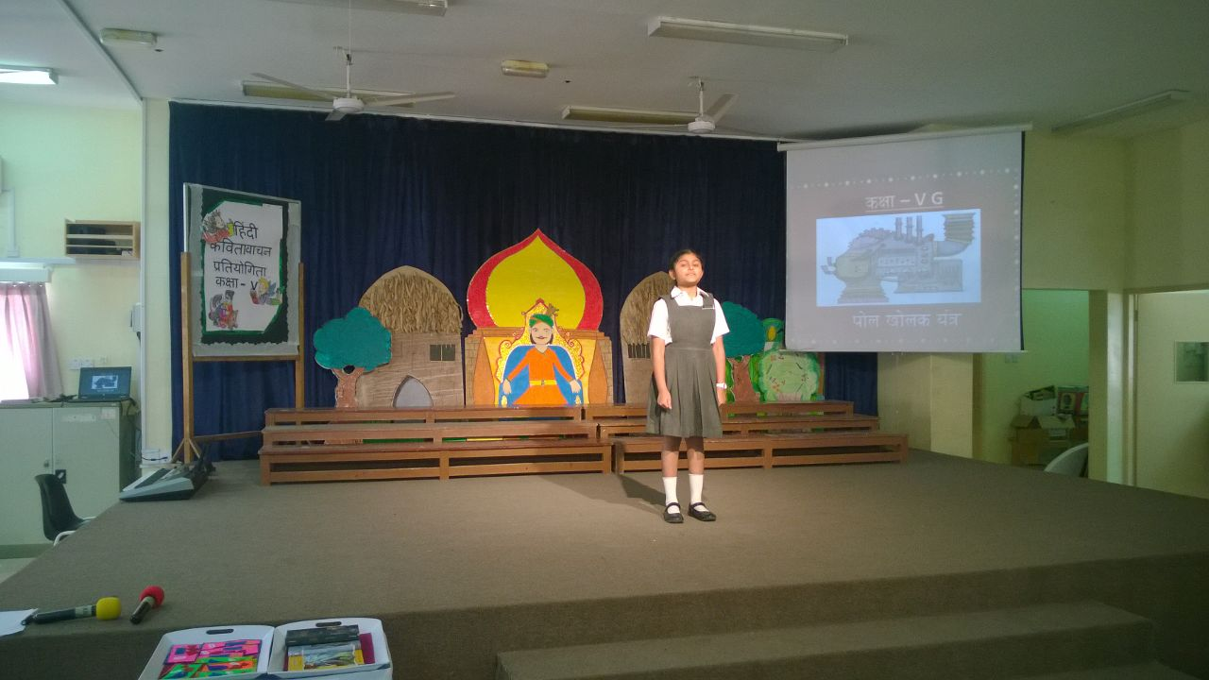

**DATE : 16-2-2017**

**Class v**

**Hindi elocution competition**

**(2016-2017)**

Ananya nagbhushan

First position

**Congratulations**

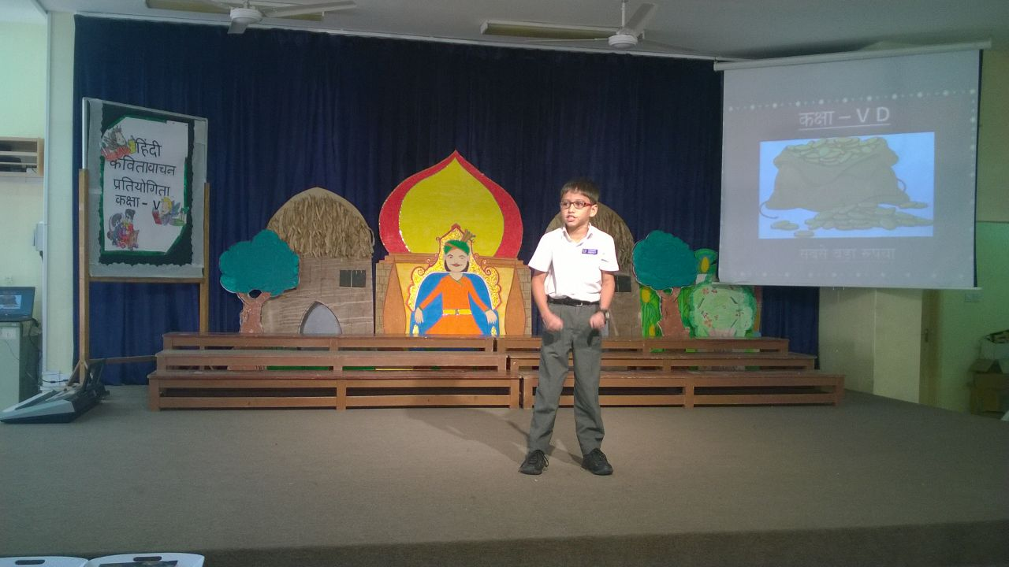

Aryan parekh

**Class v**

**Hindi elocution competition**

**(2016-2017)**

First position

**Congratulations**

**DATE : 16-2-2017**