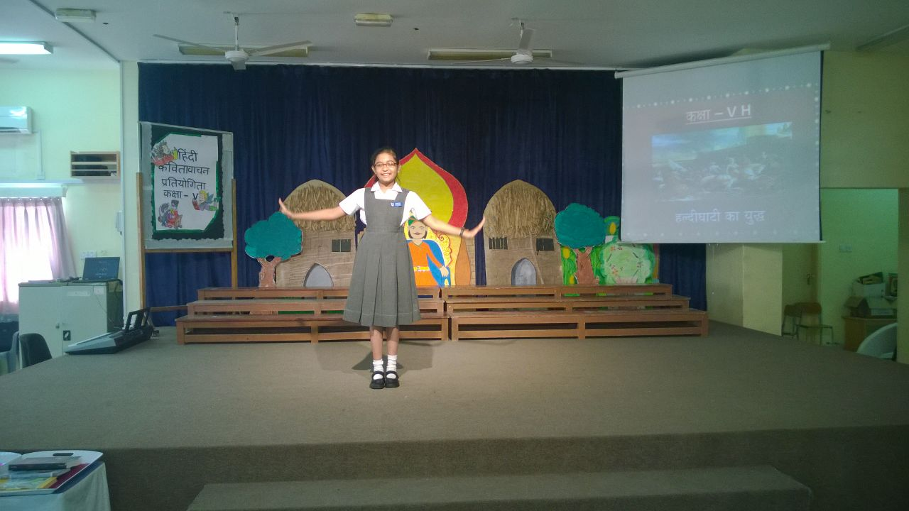

**DATE : 16-2-2017**

Inaya javed khan

**Class v**

**Hindi elocution competition**

**(2016-2017)**

third position

**Congratulations**