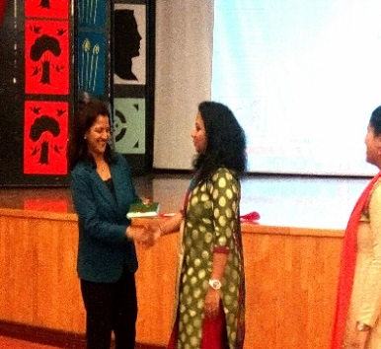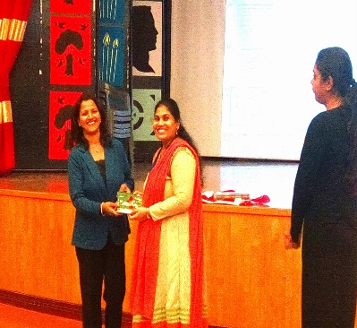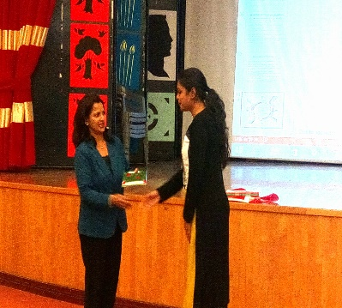

**MS.SHASHIKALA PRABHAT (V.P OF PRIMARY SCHOOL ) FELICITATING THE SPEAKERS FROM CSE**

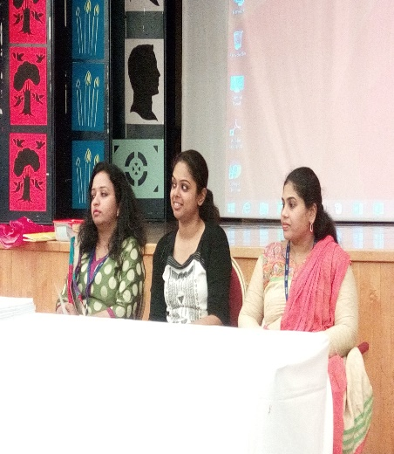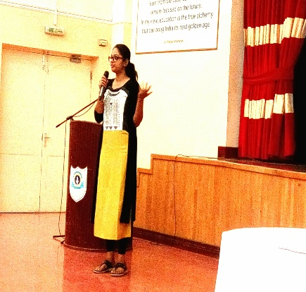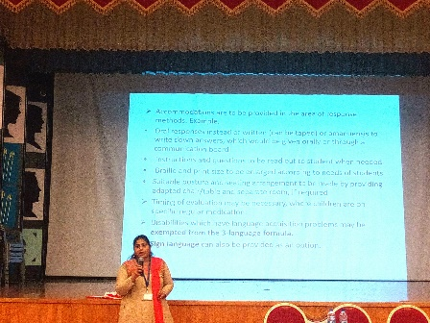

**PRESENTATION BY SPEAKERS**

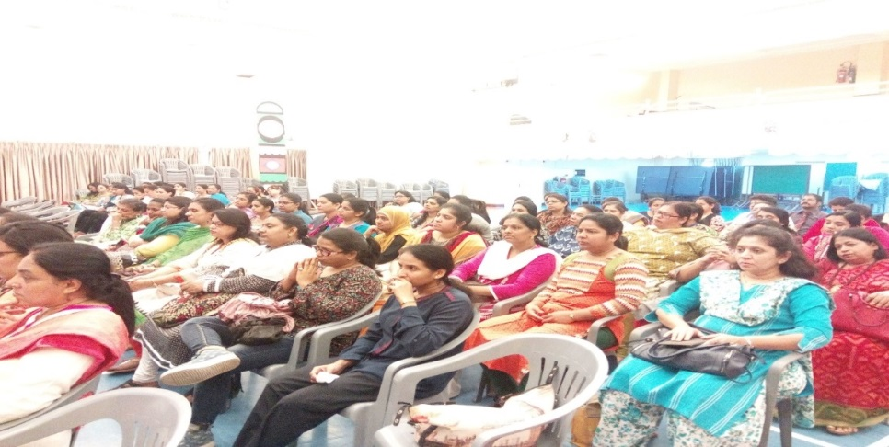

**ROLE PLAY ACTIVITY BY TEACHERS**

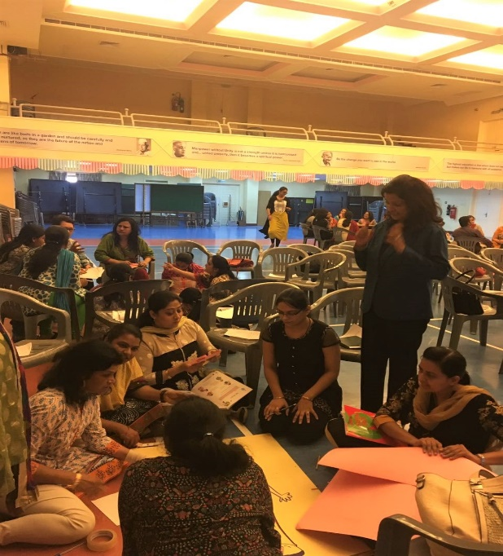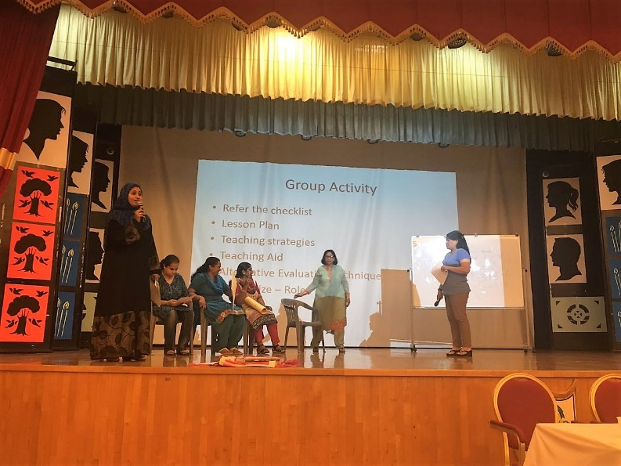

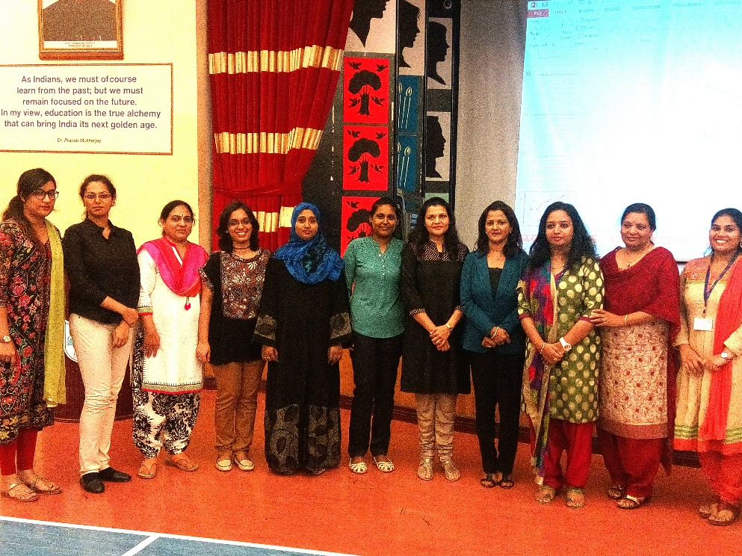

**TEAM OF SPECIAL EDUCATORS AND COUNSELORS FROM**

**ISWK AND CSE**