INDIAN SCHOOL AL WADI AL KABIR
Class: XII Comp. Sci. | Department: Computer Science | Date of submission:16-10-23
Worksheet No: 07 | Topic: MYSQL- DDL & DML | Note: Solve these queries on the system

1 | Write the difference between WHERE and HAVING in SQL? Explain with examples
2 | Write SQL commands for the following queries from (a) to (d) based on the relations Stationery and Consumer given below:  Table : Stationery Table : Consumer  - To display the details of those consumers whose address is Delhi.  - To display the details of Stationery whose price is in the range of 8 to 15.  - To display the cname, address from the table Consumer, and company and price from the table Stationery with their corresponding matching SID.  - To increase the price of all Stationery by 2.  - Write a command to display the cartesian product of these two tables.
2 | A relation named Employee is given here, you can see the structure of relation. Solve the following query based on below given structure of relation.  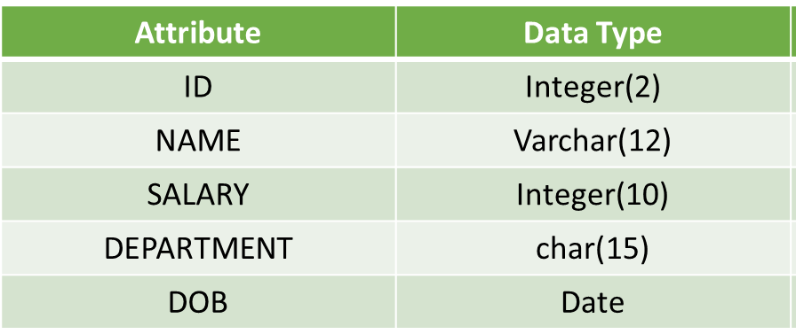  - Add one column into employee relation for storing department id of an employee.  - Write a query to change the data type of department to varchar with size of 20 and it should be NOT NULL.  - Write a query to make your ID column as a primary key.  4.Write a query to drop Department Id column.  5. Write a query to update the name of employee with ID number 2 to “SHRAVAN KUMAR”.  6. Write a query to delete the information of Production department.  9. Write a query to drop the employee relation.
2 | Consider the following relation named TEACHER and answet the questions:  ID NAME DEPARTMENT HIREDATE CATEGORY GENDER SALARY  1 Tanya Nanda Hindi 1994-03-17 TGT F 25000  2 Saurabh Sharma Art 1990-02-12 PRT M 20000  3 Nandita Arora English 1980-05-16 PGT F 30000  4 James Jacob English 1989-10-16 TGT M 25000  5 Jaspret Kaur Hindi 1990-08-01 PRT M 22000  6 Disha Seghal Math 1980-03-17 PRT F 21000  7 Sonali Mukherjee Math 1980-11-17 TGT F 24500  - To display all information about the teacher of PGT category.  - To list the names of female teachers of Hindi department.  - To list names, department and date of hiring of all teachers in ascending order of date of joining.  - To count the number of teachers in English department.  - Display the department and hire date of all the female teachers whose salary is more than 25000.  - Display the list of teachers whose name starts with J.  - Display the total salary of female teachers from Hindi department.  - Display the maximum, average, minimum and total salary of teacher department wise.  - Display the department wise average salay of those department where more than 2 teachers are working.  - Display the sum of salary of teacher who have joined after ‘1990-01-01’.  - SELECT COUNT(*) FROM TEACHER WHERE CATEGORY=’PGT’  - SELECT AVG(SALARY) FROM TEACHER GROUP BY GENDER.
3 | Create the following table structure. Table : TOYS  Column_Name DataType(size) Constraint  Toy_no Int(10) Primary Key  Toy_name Varchar(20) Unique  Toy_Type Char(10)  Price Integer  Colour Varchar(15)  Write the following queries:  - Delete the details of toys for which type is not given.  - Increment the price of all ‘Red’ colour toy by Rs. 200.  - Increment the price of all ‘Green’ colour toy by 5%.  - Decrement the price of the toy ‘Teddy’ by 3%  - Decrement the price by Rs. 50 for all the toys priced more than 500.  - Display the toy details in the Descending order of Price.  - Delete the details of the toys with the Toy Number 1725.  - Delete the details of the toys with the price less than 20.  - Rename the table as new_toys.  - Rename the column price as amount.
4 | Consider the table EXAM given below. Write commands in MySql for (i) to (iv)  Table: EXAM  No. Name Stipend Subject Average Division  1 Karan 400 English 15 FIRST  2 Aman 680 Maths 24 FIRST  3 Javed 500 Accounts NULL FIRST  4 Bishakh 200 IP 20 SECOND  5 Sugandha 400 History 10 THIRD  6 Suparna 550 Geo 5 THIRD  7 Ankit 400 NULL 10 THIRD  - To count the number of students, who have either Accounts or Informatics as Subject.  - To insert a new row in the table EXAM:  6, “Mohan”, 500, “English”, 73;  - To count the number of students according to their Subject.  - To display the subject whose average and subject is not mentioned.
5 | Write SQL Commands for (a) to (h) on the basis of table:  Table: FURNITURE  NO ITEM NAME TYPE DATEOFSTOCK PRICE DISCOUNT  1 White Lotus Double Bed 2002-02-23 3000 25  2 Pink feathers Baby Cot 2002-01-29 7000 20  3 Dolphin Baby Cot 2002-02-19 9500 20  4 Decent Office Table 2002-02-01 25000 30  5 Comfort zone Double Bed 2002-02-12 25000 30  6 Donald Baby cot 2002-02-24 6500 15  7 Royal Finish Office Table 2002-02-20 18000 30  8 Royal tiger Sofa 2002-02-22 31000 30  9 Econo sitting Sofa 2001-12-13 9500 25  10 Eating Paradise Dinning Table 2002-12-19 11500 25  - To show all the information about the Baby cots from the furniture table.  - To list the itemname which are priced at more than 15000 from the furniture table.  - To list itemname and type of those items, in which dateofstock is before 2002-02-01 from the furniture table in descending order of itemname.  - To display itemname and dateofstock of those items, in which the discount percentage is more than 25 from the furniture table.  - To count the number of items, whose TYPE is “Sofa” from the furniture table.  - To display the item name that contains letter “o”  - To update price of the furnitures by 300 whose price is more than 10000.  - Add a column item_code to the furniture table.

